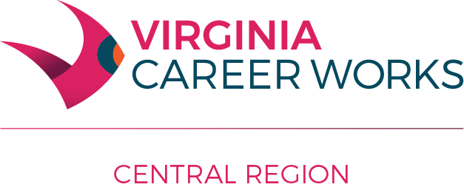

Workforce Innovation and Opportunity Act Administrative Policy #204

Subject: General Operational Provisions for Central Virginia WDB Service Providers

Effective Date: July 1, 2012

Revised: January 10, 2018

Policy Statement:

This policy conveys general operating provisions for service providers that receive WIOA funding from the WDB.

- Professional Development

The Region 2000 WDB supports and encourages an environment of quality and continuous improvement through its service provider network. As part of the commitment, WIOA-paid staff in Central Region can attend workshops, conferences and other short-term certification or training-related events with prior direct-supervisor approval. Such costs will be paid by WIOA funds under the following guidelines:

- Events must be directly related to the practice of workforce development professionals and to the employee’s daily work under the WIOA agreements with the WDB.
- Sufficient staff coverage must be available or alternate arrangements are made so as not to negatively impact delivery of services to customers.
- Costs must be reasonable within the scope of currently available approved budgets, unexpended funding and cost accounting principles.
- Any professional development event that has a combined cost in excess of $500 in total (inclusive of travel, meals etc.) requires advance written approval from the WDB Director.
- There is not a per diem rate. Only actual costs will be paid upon submission of sufficient supporting documentation/receipts. In no instance can the amount exceed Virginia state allowances in place that coincide with the date of the occurrence of the expense(s).
Note: Tuition reimbursement for college coursework for employees of WDB-contracted service providers will only be considered on a case-by-case basis. A written request with justification must be submitted to the WDB Director, who will consult with the WDB chair and/or Executive Committee before issuing a response. Any such approval will be governed by the applicable provisions of the Region 2000 Local Government Council “Personnel Rules and Regulations Employee Handbook” as may be in place at the time of the request.

- General Finance and Purchasing Provisions
- The WIOA Title 1 Youth Program will be operated by the Central Virginia Workforce Development Board.
- The Adult and One-Stop Operator services are provided by HumanKind. And the Dislocated Worker Program is operated by the Virginia Employment Commission. Most WIOA expenses incurred by the training providers are paid directly through the local WIOA fiscal agent.
- Regardless of the expense-based arrangement, the following applies to all WDB service providers with respect to WIOA funds:
  - If a service provider is not already bound to the Virginia Public Procurement Act in its overall operations, it shall follow the provisions of the Region 2000 Local Government Council Procurement Policy.
  - Purchase of any single operational-based item (equipment, furniture, consumable products) with a cost greater than $500 requires advance approval from the WIB director. (This does not apply to costs for service-related items incurred directly on behalf of customers (tuition, books, equipment, clothing etc.). Note: Other WDB policies may govern these types of costs.
  - Incurred expenses must fall within the line item cost category in the WDB approved budget in place at the time an expense is incurred.
  - WIOA service providers are expected to monitor their WDB-approved line item budgets and notify the WDB director should it become necessary to modify the line item amounts during the course of a program year.
  - All expenses charged to WIOA grant funds require supporting documentation as required by the local WIA fiscal agent.
- Food and Beverage

- Food, beverages and related supplies in relation to meetings or other similar events may only be charged to WOIA grants if they are determined as part of authorized WIOA activities that occur during a window that coincides with commonly accepted meal times. (For purposes of this policy, this means the hours of 7:00 – 9:00am; 11:30am – 1:30 pm and 5:00 – 7:00pm.
  - Such events must include external customers and professional colleagues.
    - External customers would normally be considered as program participants and/or employers.
    - Professional colleagues would normally be considered individuals outside of the organizations influence but sharing common interests and goals of the organization.
  - Service providers must document the purpose of the event, the time of occurrence, justification for food and beverage to be served, and record the names of all individuals in attendance.
- Meal and beverage costs for enrolled program participants should be documented in support of a service activity recorded in the participant’s Individual Service Strategy and determined as necessary by the case manager considering the individual circumstances. Requirements in item 1 above do not apply for these expenses.
- Charging costs for meals and refreshments for meetings, events, activities or the conduct of day-to-day business of employees is not permitted.
- Food and beverage expenses for employees in work-related travel status are permitted within allowances set by state travel regulations.
- In all cases, only actual costs (no per diem) will be paid upon submission of sufficient supporting documentation/receipts. Amounts can in no instance exceed Virginia state allowances current to the occurrence of the expense(s).

- Other Items:

- Expenses for items such as flowers and gifts cannot be charged to Central Region WIOA grant funds.

