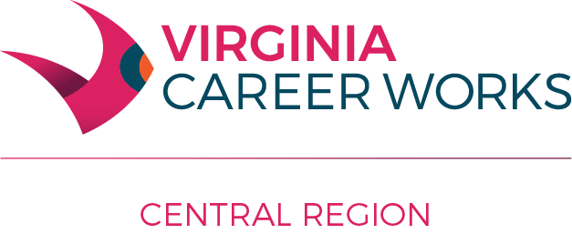

Workforce Innovation and Opportunity Act (WIOA) Administrative Policy #205

Subject: Conflict of Interest

Date of Issuance: February 13, 2013

Revised: January 10, 2018; July 12, 2022

- Policy Statement:
All members of the Central Virginia Workforce Development Board (WBD), Staff, WIOA Title 1 providers of Adult, Dislocated Worker, Youth and One-Stop Operator programs, WDB Standing Committee participants, and sub-grantees and contractors (“parties”), serve a public interest and have a clear obligation to conduct all affairs in a manner consistent with this concept. As a federally funded and local government-appointed body, all decisions of the WDB are to be based on promoting the best interest of the public good.
- General Conflict of Interest Provisions:
A. All members of the WDB and “parties” to this policy, are subject to the provisions of the State and Local Government Conflict of Interest Act, Code of Virginia Title 2.2., Subtitle 1, Part E, Chapter 31, Article 1 State and Local Government Conflict of Interests Act.
B. A member of the WDB or “party” to this policy shall neither cast a vote on, nor participate in, any decision‐making discussions related to provision of services by such member (or by an organization that such member directly represents); nor on any matter which would provide any direct benefit to such member or the family of such member.
C. Any WDB member or “party” to this policy (or specific entity represented by that member) who participates in the development of contract specifications or standards is prohibited from receiving any direct financial benefit from any resulting contract.
D. Any WDB or “party” to this policy who participates in a WDB/council decision relating to specific terms of a contract, the determination of specific standards for performance of a contract, the development of Invitations for Bid (IFB) or Requests for Proposals (RFP) or other such bid processes leading to a contract, or any similar decisions is prohibited from receiving any direct financial benefit from any resulting contract. In addition, no corporation, partnership, sole proprietorship, firm, enterprise, franchise, association, trust, foundation or other entity shall receive the contract if it would create a conflict of interest for the WDB or Youth Standing Committee member who participated in this manner.
E. Each WDB and Youth Standing Services Committee member shall file a statement of economic interest on a form and in the timing identified by staff, as a condition of assuming membership and while serving as a WDB or Youth Standing Committee member. The Chief Local Elected Officials shall determine the composition of the statement of economic interest.
F. Any WDB or “party” to this policy with a potential or actual conflict of interest must disclose that fact as soon as the potential conflict is discovered. If it should be determined during a meeting that a conflict of interest exists, the member must verbally declare such conflict of interest, such declaration must be clearly noted in the minutes, and such member must excuse himself from the remainder of the discussion and voting on that item. Each board/council member is responsible for determining whether any potential or actual conflict of interest exists or arises for him or herself during his tenure on the board/council.
G. If a contract or purchase is made by the WDB involving a member with a conflict of interest, the WDB staff shall verify for the file that the contract or purchase was adequately bid or negotiated and that the terms of the contract or price of the purchase are fair and reasonable.
H. WDB members who are also employees of entities serving as One Stop operator or service provider shall not serve as a voting member on any committees that deal with oversight of the service delivery system or allocation of resources that would potentially be allocated to that member’s program.
III. Other Related Provisions:
- Conducting Business Involving Family Members:

- No family member of any WDB member or “parties” to this policy will receive favorable treatment for enrollment into WIOA services provided by, or employment with, the WDB or any of its service providers.

- The WDB’s service providers will also avoid entering into any agreements for services with a family member. No direct employment supervision will be permitted by family members as defined herein. When it is in the public interest for the service provider to conduct business (only for the purpose of services to be provided) with a family member, the service provider will obtain approval from the WDB’s before entering into an agreement. All correspondence will be kept on file and available for monitoring and audit reviews.
- Conducting Business Involving Close Personal Friends and Associates:
WDB members, and “parties” to this policy will be particularly aware of the varying degrees of influence that can be exerted by personal friends and associates and, in administering the Workforce Innovation and Opportunity Act locally, will exercise due diligence to avoid situations which may give rise to an assertion that favorable treatment is being granted to friends and associates. When it is in the public interest to conduct business with a friend or associate of a WDB member, or “parties” to this policy, a permanent record of the transaction will be retained.

Definitions:
Family member means (1) a relative related by either blood, marriage or adoption and (2) any other person residing in the same household as the member, who is a dependent of the member or of whom the member is a dependent.
Dependent means any person, whether or not related by blood or marriage, which receives from the member, or provides to the member, more than one‐half of his financial support.

