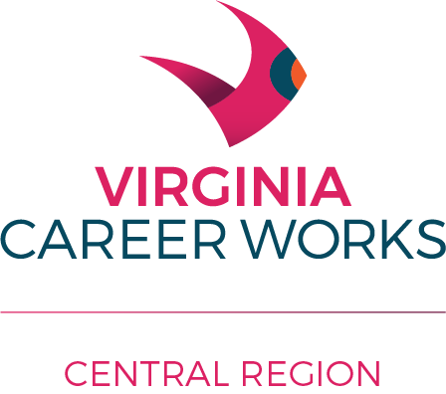
Central Virginia Workforce Council
April 27, 2021
Electronic and in person meeting
Participating:
Kenneth Brown, Campbell County
John Hinkle, Appomattox County
Jennifer Moore, Amherst County

Others:

Gary Christie
Lori Cumbo
Keith Cook
Michael Hertzler
Tim Saunders

Welcome
Gary Christie welcomed the Committee and briefly reviewed the purpose of the meeting, to appoint members to the Central Virginia Workforce Board and to certify the Business and Labor percentages for 2021-2022.

Additions to the Central Virginia Workforce Board
Upon a motion by Ms. Moore, seconded by Mr. Hinkle, the Council approved the following new members of the Workforce Board:

  - Samuel Pinn, Sr., United Cherokee Indian Tribes of Virginia, 2021-2024
  - Michael Hertzler, Virginia MetalFab Sheet Metal, Appomattox, VA, business representative
  - Nate Mahanes, Virginia Department for Aging and Rehabilitative Services, mandated partner, completing an unexpired term, 2019-2022

Certification of the 2021-2022 Central Virginia Workforce Board
Upon a motion by Ms. Moore, seconded by Mr. Hinkle, the Council approved the Board Members for the 2021-2022 year and certified the percentages of Business (53%) and Labor (21%) representation.

Update on the Career Center/VEC Activities
Keith Cook, Lori Cumbo and Tim Saunders updated the Council on the activities at the Career Center as they work to reopen and restart services from the pandemic’s impact. There was good discussion about the difficulty in hiring.

Update on the search for a Workforce Development Director
Gary Christie reported that applications have been received and screening has started in the search for a Workforce Development Director. July is the target date for having a new Director identified.

Thanks for your service
Gary thanked the Council for their service and indicated that there would be another meeting this summer to approved the Workforce Board’s budget.

