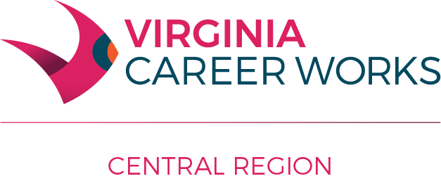

Workforce Innovation and Opportunity Act (WIOA) Operating Procedure 303

Subject: Promotional Materials

Date of Issuance: February 19, 2013

Revised: January 10, 2018

Part I – Development of WIOA Promotional Materials

Federal Office of Management and Budget (OMB) Circulars revised through 2004 set guidelines limiting use of Federal grant funds for promotional activities.

As such:
- WIOA funds made available to service providers from the Central Virginia Workforce Development Board (WDB) may be used for costs of outreach, awareness, public relations, and informational activities only when such costs are incurred to communicate with the public and press pertaining to specific activities or accomplishments that result from the performance of the WDB award.
- Costs of renting a booth at a job fair, career fair, or business-to-business expo are also permitted.
- Outreach, advertising, public relations, and informational activities may highlight the programs or services provided by the grants, but may not focus on an organization including workforce centers, a governmental agency, a business, a partner or sub-contractor, or any other service provider.
- All such materials described above must include the following logo and language:
(name of activity, event, service etc.) is funded by the Workforce Innovation and Opportunity Act and adheres to equal opportunity guidelines. The Central Virginia Workforce Development Board is an equal opportunity employer/program. Auxiliary aids and services are available upon request to individuals with disabilities. The full Equal Opportunity Provisions policy can be found at: http://region2000works.org/wp-content/uploads/2014/10/AP-201_Equal-Opportunity-Provisions.pdf. If you need to contact the local Equal Opportunity Representative for The Central Virginia Workforce Development Board area write or call:
Vicki M. Tanner, MPA
Lead Workforce Compliance Monitor
Workforce Development Services
Virginia Community College System
Arboretum III
300 Arboretum Place, Suite 200
Richmond, VA 23236
phone: 804-819-1682| fax: 804-819-1699| online: http://www.vccs.edu
Ben Bowman
Workforce Development Director
828 Main Street, 12th Floor
Lynchburg, VA 24504
Phone: (434) 845-5678, ext. 221
Email: bbowman@region2000.org
TDD VA Relay Center 1-800-828-1120 or 711

- Costs of any giveaways such as pens, pencils, portfolio pads, flash drives, CDs, shirts, etc. that are produced or purchased with WIOA funds will only be permitted under limited circumstances and require prior approval from the WDB director. Service providers are encouraged to find non-federal resources to pay for giveaway items, or seek donations of these items by partners.

Part II – Display of Promotional Materials of External Organizations in the VA Career Works Lynchburg Center

No organization, employee, contract worker, or volunteer will be allowed to solicit or sell merchandise or display materials that promote services for profit in WDB- leased property.

This does not apply to fee-for-service offerings from any member of the Virginia Workforce Network as defined at § 2.2-2674.1 of the Code of Virginia or other not-for-profit organizations that enter into a Memorandum of Understanding/Agreement with the WDB.

