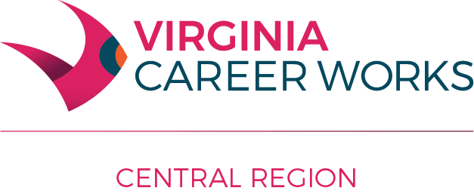

Workforce Innovation and Opportunity Act Program Policy #103

Subject: Low Income and Self-Sufficiency

Effective Date: November 14, 2012

Revised: January 10, 2018

References: VWL #17-01

Policy Statement:

- To provide the current Poverty Guidelines and the 70% Lower Living Standard Income Levels (LLSIL) in Central Region, Area VII, used in determining an individual as low-income under the Workforce Innovation and Opportunity Act (WIOA).

- To provide guidelines regarding the use of the current 100% Lower Living Standard Income Levels in Central Region, Area Vii, as a minimum when setting the Local Workforce Development Area's standard of economic self -sufficiency for training and employment purposes.

Definitions:
Under the Workforce Innovation and Opportunity Act (WIOA):

Section 3 (36) LOW-INCOME INDIVIDUAL.—

(A) IN GENERAL.—the term ‘‘low-income individual’’ means an individual who—
(i) receives, or in the past 6 months has received, or is a member of a family that is receiving or in the past 6 months has received, assistance through the supplemental nutrition assistance program established under the Food and Nutrition Act of 2008 (7.S.C. 2011 et seq.), the program of block grants to States for temporary assistance for needy families program under part A of title IV of the Social Security Act (42 U.S.C. 601 et seq.), or the supplemental security income program established under title XVI of the Social Security Act (42 U.S.C. 1381 et seq.), or State or local income-based public assistance;
(ii) is in a family with total family income that does not exceed the higher of—
(I) the poverty line; or
(II) 70 percent of the lower living standard income level;
(iii) is a homeless individual (as defined in section 41403(6) of the Violence Against Women Act of 1994 H. R. 803—12 (42 U.S.C. 14043e–2(6))), or a homeless child or youth (as defined under section 725(2) of the McKinney-Vento Homeless Assistance Act (42 U.S.C. 11434a(2)));
(iv) receives or is eligible to receive a free or reduced price lunch under the Richard B. Russell National School Lunch Act (42 U.S.C. 1751 et seq.);
(v) is a foster child on behalf of whom State or local government payments are made; or
(vi) is an individual with a disability whose own income meets the income requirement of clause (ii), but who is a member of a family whose income does not meet this requirement.

*SPECIAL RULE- For the purpose of this subsection, the term "low-income," used with respect to an individual, also includes a youth living in a high-poverty area.

Lower Living Standard Income Level - income level (adjusted for regional, metropolitan, urban, and rural differences and family size) determined annually by the Secretary of Labor based on the most recent lower living family budget issued by the Secretary.

Self-sufficiency - employment that pays at least 100% of the Lower Living Standard Income Level; self­ sufficiency for a dislocated worker may be defined in relation to a percentage of the layoff wage.

Economic self-sufficiency standard - an economic standard that meets or exceeds the State's minimum requirement that specifies the income needs of families by family size, the number and ages of children in the family, and sub-state geographical considerations (not a performance measure).

Guidance:
The following guidelines are to be used in determining low-income eligibility in Central Region (LWDS 07). Poverty Guidelines are to be used for the “poverty line.” The 70% Lower Living Standard Income Level appropriate to the applicant’s place of residence should be used to determine eligibility, where appropriate.

70% Lower Living Standard Income Level Metro-Level - SOUTH Region (Central Region)
Size of Family. Unit | 70% LLSIL
1 | ($9,216)
2 | (15,101)
3 | 20,727
4 | 25,588
5 | 30,201
6 | 35,321
For the values in parentheses, the Poverty level is higher for the corresponding family size. For each family
member above 6 add $5,120.
Federal Register, May 23, 2017- U.S. Department of Labor- Employment and Training Administration Workforce Innovation and Opportunity Act (WIOA) 2017: Lower Living Standard Income Level (LLSIL)

2017 Poverty Guidelines for the 48 Contiguous States and the District of Columbia
Size of Family'. Unit | Poverty Guideline
1 | $12,060
2 | 16,240
3 | 20,420
4 | 24,600
5 | 28,780
6 | 32,960
7 | 37,140
8 | 41,320
For family units with more than 8 members, add $4,180 for each additional member.

Federal Register, January 31, 2017 - Department of Health and Human Services, Annual Update of the HHS Poverty Guidelines

The following table is used to determine the minimum level for establishing self-sufficiency criteria in Central Region. They are not to be used in determining low income for youth or adults.

100% Lower Living Standard Income Level Metro Level - SOUTH Region SELF-SUFFICIENCY
(Central Region)
Size of Family Unit | 100% LLSIL
1 | $13,166
2 | 21,573
3 | 29,609
4 | 36,555
5 | 43,144
6 | 50,459
For each family member above 6 add $7,315.

Federal Register, May 23, 2017 - U.S. Department of Labor- Employment and Training Administration Workforce Innovation and Opportunity Act (WIOA) 2017: Lower Living Standard Income Level (LLSIL)

